**المــركز الإقليــمي لاتفـاقيــة استــوكهلم لدول شمــال إفريقيــا**

**Stockholm Convention Regional Center for North Africa Region**

Activity Report 2016- 2019

**Table of Contents**

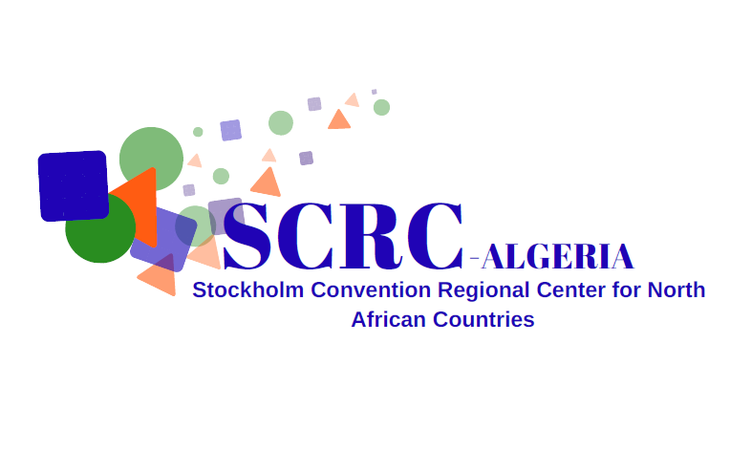***I. Overview***

***II. Main achievements***

***III. Capacity building activities and technology transfer***

***IV. Activities promoting the environmentally sound management of pops***

***V. Representativeness and networking***

***VI. Institutional communication.***

***VII. Conclusion***

1. ***Presentation***

The regional centers were created in institutions with the expertise and capacity to provide technical assistance and capacity building to eligible countries.

The centers have been mandated to follow guidelines on technical assistance and technology transfer to ensure effective regional delivery of technical assistance in a highly professional manner in conjunction with the implementation of a methodology for their assessment of their performance on the basis of specific criteria.

However since 2009, the National Center for Cleaner Production Technologies (Body under the Ministry of the Environment and Renewable Energies) is home to the Stockholm Convention Regional Center for Eight (08) countries in the North Africa region. (Algeria, Morocco, Tunisia, Egypt, Libya, Mauritania, Mali and Niger),

However since 2009, the National Center for Cleaner Production Technologies (Organization under the Ministry of Environment and Renewable Energy) houses the Stockholm Convention Regional Center for the eight (08) countries in the North Africa region (Algeria, Morocco, Tunisia, Egypt, Libya, Mauritania, Mali and Niger),

At the Seventh Conference of the Parties to the Stockholm Convention, held in Geneva from 4 to 8 May 2015, the secretariat of the convention decided to renew the mandate of the NCCPT for the period 2016-2019.

The objective of the SCRC-NCCPT is to conduct capacity-building and technology transfer activities through technical workshops and to promote the Best Available Techniques (BAT) and Good Environmental Practices (BEP) activities. In this regard, SCRC-CNTPP is responsible of providing technical assistance and promoting technology transfer to developing countries and countries with economy in transition to support their obligations under the Convention in the NIP Implementation Plans

The autonomous institutions serving as regional centers operate under the authority of the secretariat of the Conference of the Parties, which is the decision-making body of the Convention.

Our priority is to be closer to the concerns of the eight countries of the region, taking into account its specificity and to provide the necessary technical assistance while supporting all the initiatives of financing the actions undertaken at the regional level for the elimination of persistent organic pollutants.

1. **Main achievements.**

The Stockholm Convention Regional Center for the North African Region was marked by greater interactivity fostered by exchange and synergy among the countries of the region during the various workshops organized.

The SCRC contributes to achieve the 17th objective of Sustainable Development, which is the transfer of technologies.

Present at each of organized workshops, experts from all around the world for the transfer of knowledge and global experience in the field of POPs thanks to the efforts made with the focal points during the workshops and the official declaration of Algeria to integrate the draft inventory of 2000 tons of PCBs and 30 tons of mercury. In addition to these achievements, the SCRC has four experts in PCB and pesticide analysis.

Thanks to the workshops carried out in 2017, the exchange, the sharing and the synergy between the participants, the SCRC was able to start in partnership with the Med-Pol the program of elimination of 2000 tons of PCBs and 30 tons of mercury in the Mediterranean.

1. ***Capacity building activities and technology transfer***
   * + 1. **Capacity-building workshop on the updating of the National Implementation Plans of the Stockholm Convention** on Persistent Organic Pollutants (POPs) added to the annexes of the Convention since the 5th Conference of the Parties to the Stockholm Convention, and this in the context of the implementation of Article 7 of the Stockholm Convention which aims to facilitate the development, implementation and updating of the NIPs for the implementation of their obligations towards the Convention.

*Alger le 26 – 28 juillet 2016*

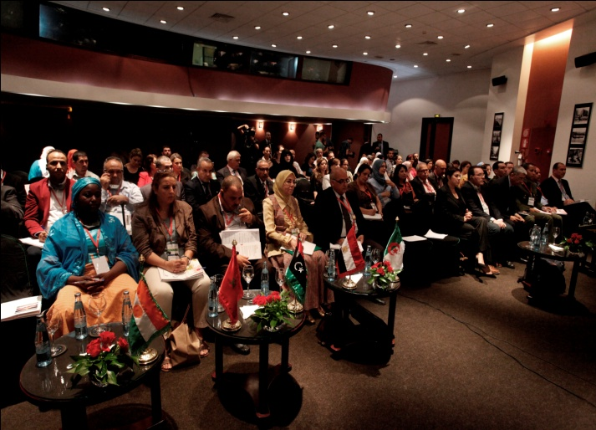

***Workshop recommandations***

* Strengthen and diversify types of communication on POPs in countries (eg Paperbacks, leaflets, film, videos, TV shows ...).
* Increase NGO and civil society awareness of POPs and encourage them to duplicate efforts to raise awareness among citizens.
* Strengthen national cooperation and exchange of information between the health, environment, civil protection, chambers of commerce, customs and gendarmerie services, in order to become aware of the impacts caused POPs exposure and provide a platform for exchange at the regional level.

1. **Workshop on “Determination of Organochlorine Pesticides and Indicator PCBs in Serum”**

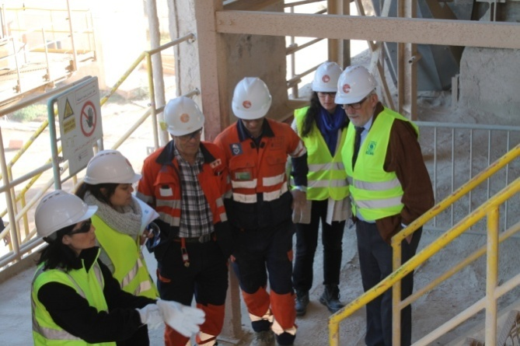***October 22 to 26, 2017 at the National Center of Toxicology Algiers, Algeria***

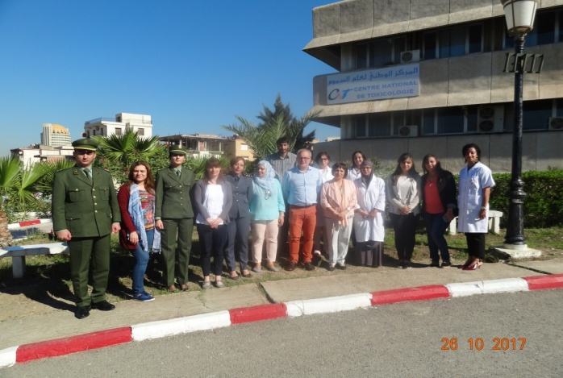 Under Article 9 of the Stockholm Convention, which stipulates that each party shall facilitate or undertake the exchange of information relating among others about the risks of POPs and identification means and in order to NCT laboratory of reference for Algeria and possibly for the whole region and to strengthen the capacities of Algerian experts and the Center's managers.

***Workshop recommandations***

* Make the National Center of Toxicology a reference laboratory for the entire region
* Duplicate training for all the countries covered by the Regional Center

1. **Round table on "Co-incineration of POPs / PCBs - energy recovery and alternative fuel"**

***November 29, 2017 at the headquarters of the NCCPT***

***Lafarge visit as part of the round table***

The purpose of this roundtable, as well as the visit of the Meftah cement plant, is to find a compromise between all parties involved in the treatment, upgrading and disposal of waste and that we must find new opportunities for achieve sustainable development and that landfill is no longer a solution, and go to economic and environmental thinking.

1. **Regional Workshop on Improvement and Harmonization of Persistent Organic Pollutant Inventories and the Action Plan**

***Rabat, Morocco from October 30 to November 02, 2017***

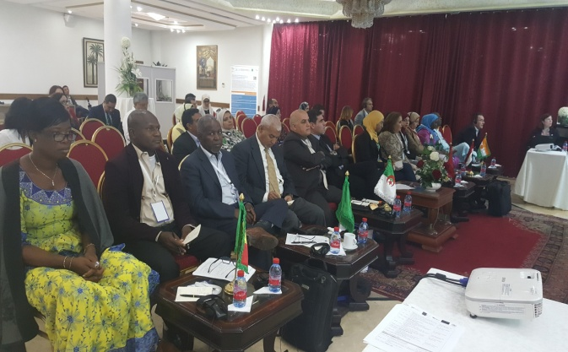

One of the results of the April workshop on the co-incineration of PCBs is precisely the organization of a workshop in Morocco and this in order to be able to visit the Moroccan platform for the elimination of PCBs and to be able to share the experience with all representatives of the region

* Organize a visit to Europe to see the PBDE recycling plants
* Create an exchange network for sharing experiences and other activities that countries have.
* Organize training on methods of analysis and control of POPs
* Inventory national capabilities in POPs analysis methods and release an accredited regional laboratory for POPs identification and analysis

**IV.** **Activities promoting the environmentally sound management of POPs**

* + - 1. **Regional workshop on the management and elimination of POPs / PCBs by the co-incineration method**

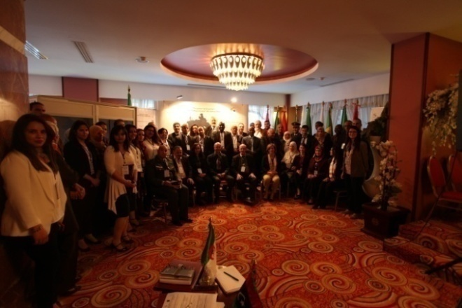***the 04, April 05, 2017 hotel OASIS, Algiers, Algeria***

Capacity building workshop for national, international and country focal points served by the Stockholm Convention Regional Center.

Among the objectives of this workshop are the identification of experiences and the challenge of POPs / PCB waste management in the MENA region:

• Become aware of the potential and solutions offered by the co-incineration of POPs waste in cement kilns.

• It saw the participation of eighty people between representatives of focal points, members of the POPs Committee, and all relevant sectors of Algeria.

* Update of NIPs to the new POPs introduced in the annexes of the Convention
* A special day for new Persistent Organic Pollutants
* The next workshop in Morocco to visit the PCB storage platform.
* Organize activities in the different countries of the region
* Revision of regulatory texts relating to POPs

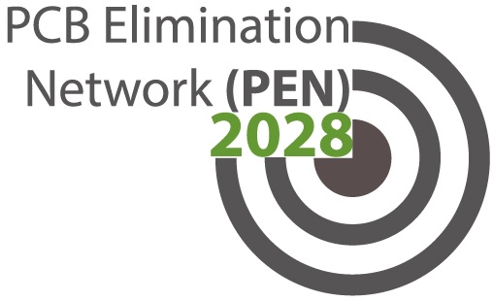**2.** The SCRC / NCCPT accompanied by Med POL experts was able to identify 800 tons of PCBs for disposal as part of the Child 1.1 project with the expertise of Med-POL.

This project is related to the reduction of pollution from harmful chemicals and wastes in hot spots in the Mediterranean. In a first phase concerning industrial, 9 companies, 300 tons of PCBs have been identified and validated by international experts from UNEP. The export phase out of these PCBs will start in 2019. The second phase of identification and disposal, which will run until 2021, will involve hospitals, schools and public administrations and will cover 500 tones of PCBs.

1. ***Representativeness and networking***

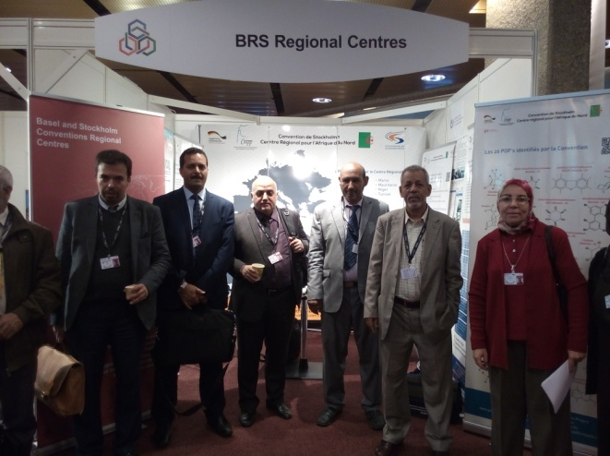

* + 1. **Participation in the COP**

***From 24.04 to 05.05.2017 ICCG, Geneva, Switzerland,***

The Conference of the Parties saw the registration of the three chemicals, one of the main recommendations was to improve the synergies between the three existing conventions.

* + 1. **Adhesion to the PEN PCB disposal network**

The National Center for Cleaner Production Technologies NCCPT, housing the Stockholm Convention Regional Center is designated as a member of the PCB Elimination Network (PEN) Advisory Committee and also as representative of the Stockholm Convention and / or the Basel Convention. Centers (SCRC / BCRC).

After a difficult evaluation of the various applications, the PEN secretariat welcomes the NCCPT, Algeria, as well as the CRCB / SCRC of Indonesia, as representatives of the CRCB / SCRC on the PEN Advisory Committee. This selection is based on the Center's expertise and takes into account the balance between the different regions that have applied to the PEN Advisory Committee.

The purpose of this application is to foster collaboration, support the implementation of the PEN work plan, and facilitate the exchange of information and share experiences among different stakeholders.

* + 1. **Annual Joint Meeting to Enhance Cooperation and Coordination among Regional Centers under the Basel and Stockholm Conventions**

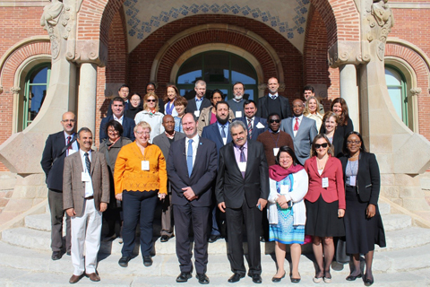***06-07 November 2017***

***Sant Pau, Barcelona, Spain***

The face-to-face meeting of the regional centers under the Basel and Stockholm conventions, organized by the secretariat of the three conventions aims to:

* Strengthen cooperation and coordination between the regional centers of the Basel and Stockholm conventions;
* Promote and enhance synergies in the provision of technical assistance under the Basel, Rotterdam and Stockholm conventions.

The meetings in regional centers the opportunity to exchange experiences and to discuss with them, with the Secretariat and other relevant funds, including bilateral and multilateral donors, on the questions asked and required by the relevant meetings of the conferences Parties.

* + 1. **Presentation workshop and validation of the PNM of Algeria**

The CRCS, under the request of the focal point of the Stockholm Convention of Algeria, under the patronage of the Ministry of Environment and Renewable Energies, a presentation workshop of the PNM, with the presence of the experts who developed it the December 13, 2019 at the MEER.

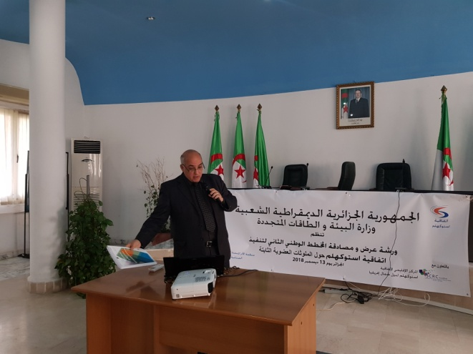

* + 1. **Annual joint meeting to enhance cooperation coordination between the regional centers under the Basel, Stockholm conventions**

### *Geneva, Switzerland from 15 November to 16 November 2018*

Face-to face meetings of the regional centers under the Basel and Stockholm conventions are convened on an annual basis to:

* Enhance cooperation and coordination between the regional centers of the Basel and Stockholm conventions
* To promote and enhance synergies in delivery of technical assistance under the Basel, Rotterdam and Stockholm convention

1. **Institutional communication**

Under Article 10 (4), the Stockholm Convention Regional Center may use means of communication such as the guide, the magazine ... to provide information on POPs.

Paragraph 2 states that the SCRC ensures that the public has access to public information through the website and flyers.

* + 1. Realization of a guide on Persistent Organic Pollutants in order to simplify the understanding of these molecules and the alternatives

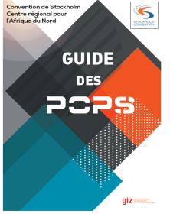

* + 1. Revitalization of the website www.popsalgerie.com with creation of specific sessions for each focal point of the countries served by the SCRC

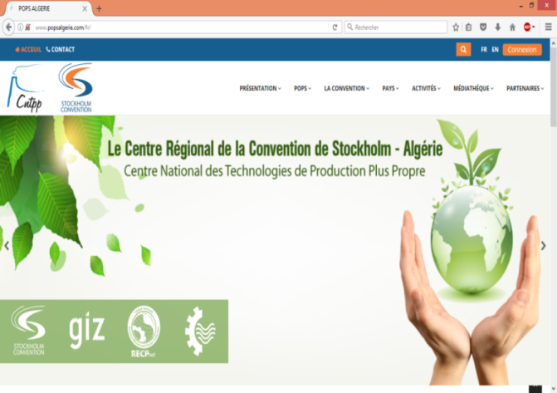

* + 1. Review dedicated to events and information on SCRC activities and countries served and POPs news.

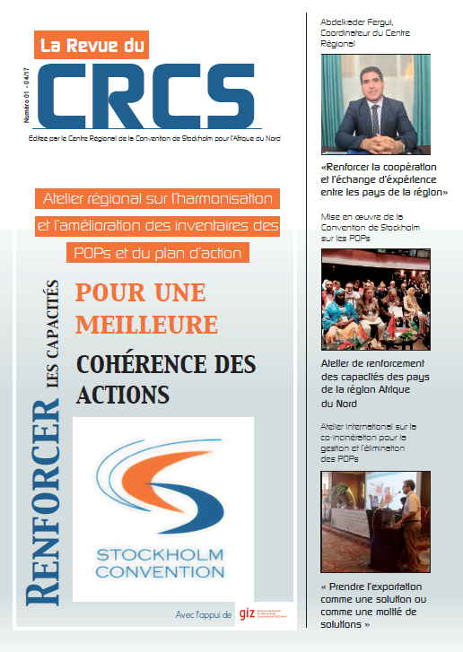

* + 1. Dissemination of a Flyer on POPs and the Stockholm Convention

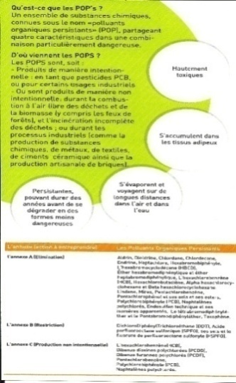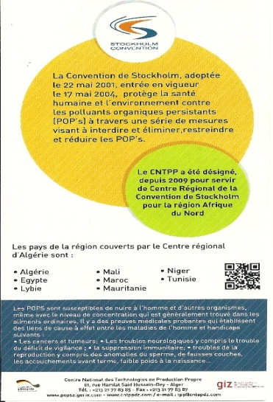

* + 1. le CRCS à élaborer un dépliant regroupant toutes les activités du CRCS pendant ce dernier mandat, en trois langues.

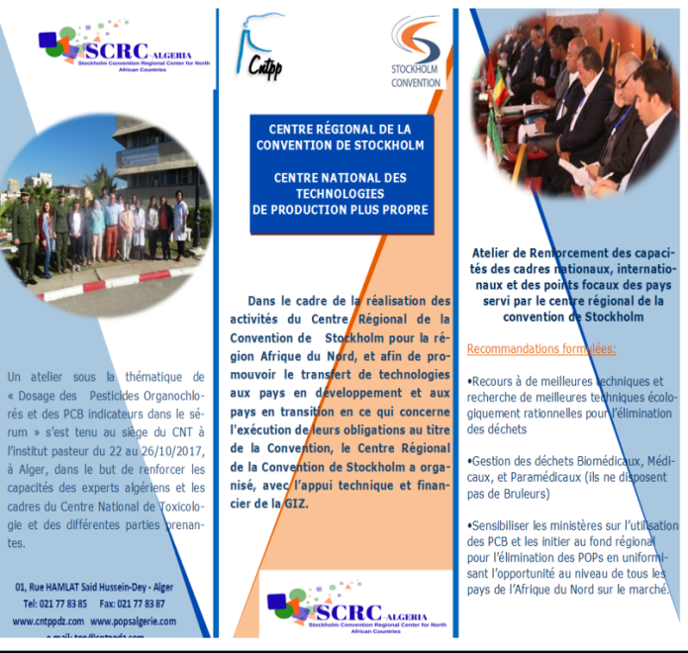

**Conclusion**

The year 2017 saw a series of activities organized to support the NIP of the Stockholm Convention and the countries of the region. The activities of 2017 enabled the focal points and all stakeholders to the CS drew important turning points in the fight against POPs and possible solutions could be seen concretely during the various workshops.

The SCRC carries out the mission that has been entrusted to him both in his country Algeria and throughout the North African region, as proof, he shared the knowledge and latest technologies available to his colleagues at the National Center for Toxicology providing its managers with state-of-the-art training in the field of POPs analysis.

And it is on this good track that the SCRC intends to pursue its missions, with greater efficiency, sharing of technology transfer and capacity building in order to meet the challenges of a future free of POPs.